**Deployment Diagram**

In the context of the Unified Modeling Language (UML), a deployment diagram falls under the structural diagramming family because it describes an aspect of the system itself. In this case, the deployment diagram describes the physical deployment of information generated by the software program on hardware components. The information that the software generates is called an artifact. This shouldn't be confused with the use of the term in other modeling approaches like BPMN.

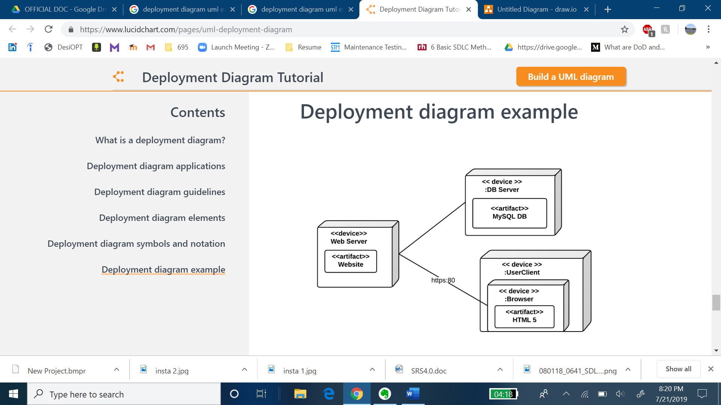

**Component Diagram**

The purpose of a component diagram is to show the relationship between different components in a system. For the purpose of UML 2.0, the term "component" refers to a module of classes that represent independent systems or subsystems with the ability to interface with the rest of the system.

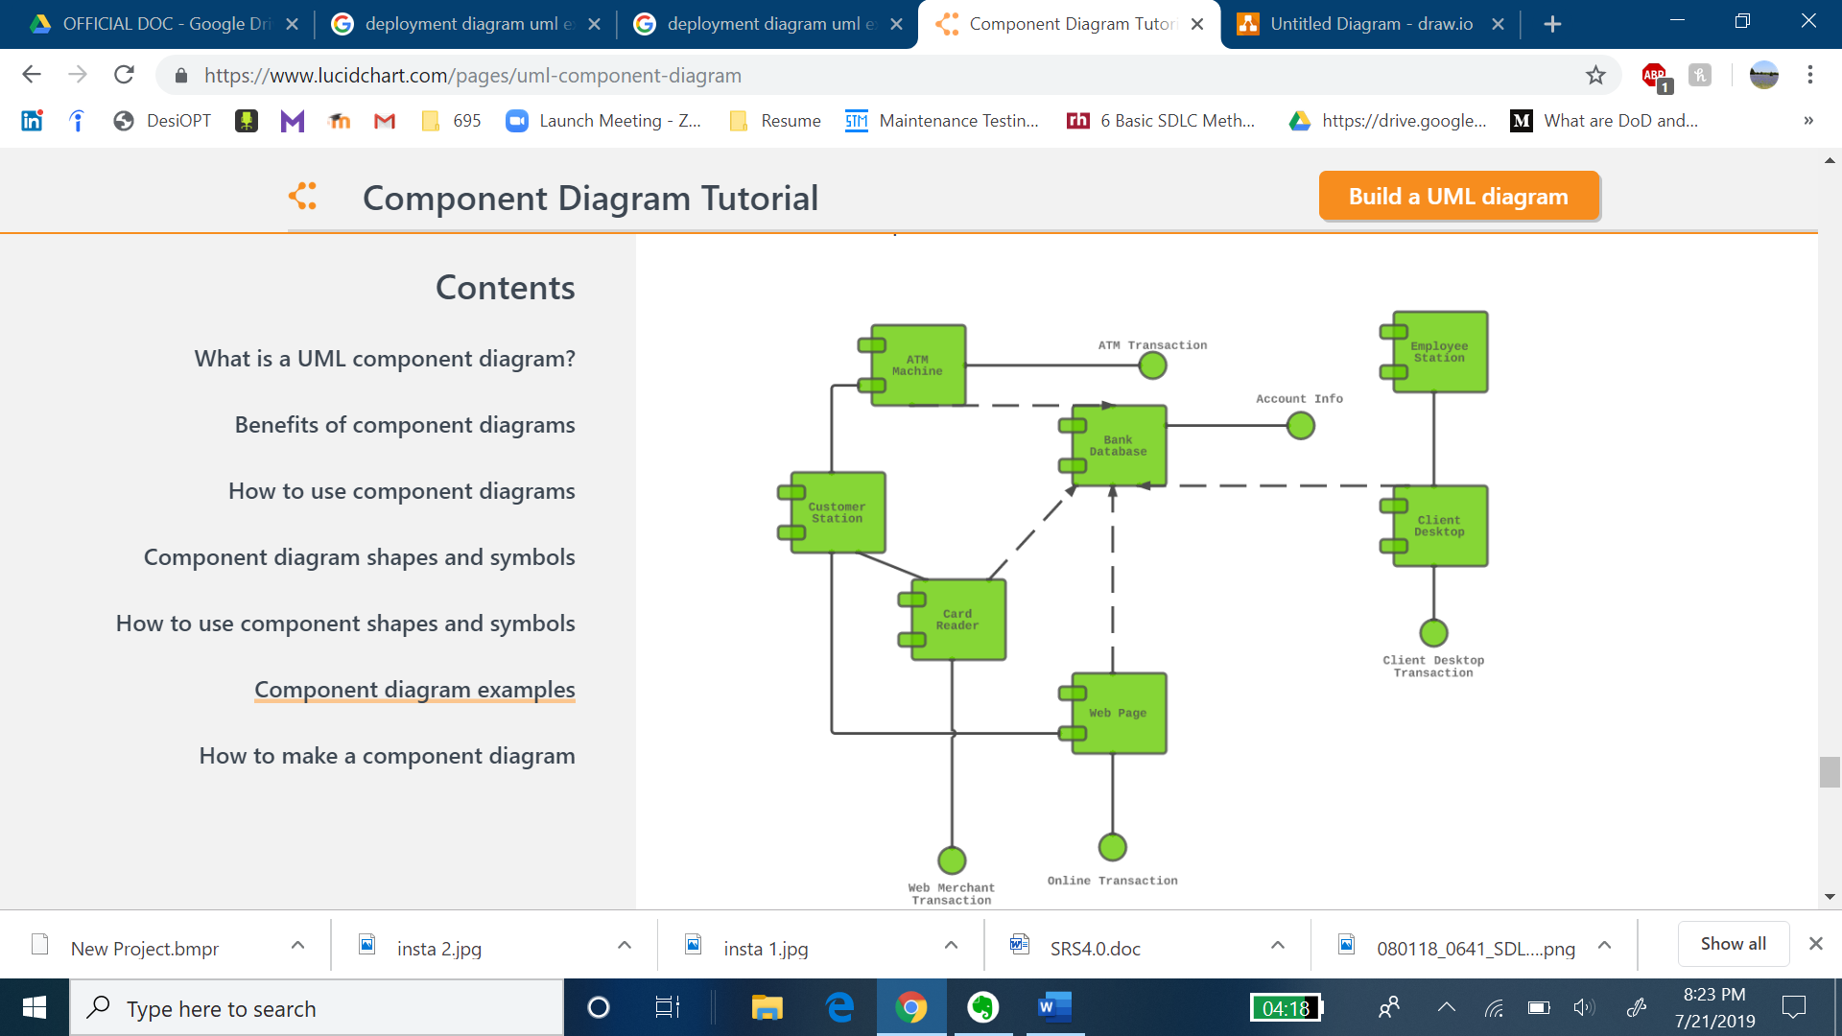

**Object Diagram**

An object diagram focuses on the attributes of a set of objects and how those objects relate to each other. For instance, in this object diagram below, all three bank accounts tie back to the bank itself. The class titles show the type of accounts (savings, checking, and credit card) that a given customer could have with this particular bank. The class attributes are different for each account type. For example, the credit card object has a credit limit, while the savings and checking accounts have interest rates.

